It’s On Blue Training

Banner Quick Reference Documentation

Overview: www.indstate.edu/itsonblue
For Fall 2015, students required to complete the It’s On Blue Training must meet all of the following criteria:
- Undergraduate
- Degree-seeking
- Main “role” within the university is a student (excludes faculty and staff)

Failure to complete the training will result in a registration hold (T9-It’s on Blue Required Training)

How to look up your student in Banner
SEADETL: Identifies who is required to take the It’s On Blue Training by individual student
To look up student:
- ID: key the student id into this field {Tab}
- Term: key the current term (201505 for Fall 2015) {Ctrl+PageDown or Next Block }
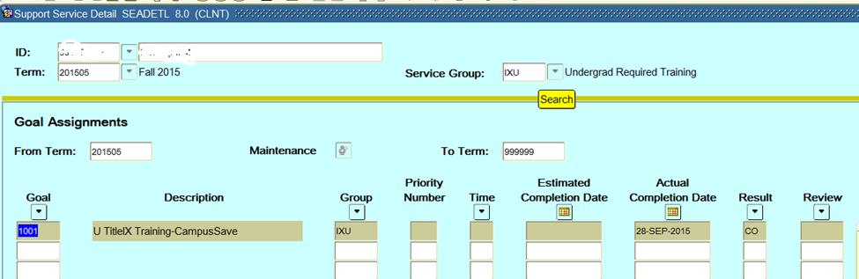
IF Goal Code = 1001, student is required to complete the It’s On Blue Training Fall 2015
IF Goal Code = anything other than 1001, student is not required to complete the It’s On Blue Training Fall 2015
IF Result Code = CA (Completed-alternative training), CO (Completed), or EX (Exemption-not required), student has completed the training and a T9 registration hold WILL NOT be placed on their account.
IF Result Code = Blank and Goal Code = 1001, student HAS NOT completed training and a T9 registration hold WILL be placed on their account.
If training has not been completed, training is accessed by logging into: https://www.campusclarity.com/signup
For It’s On Blue questions, please contact itsonblue@mail.indstate.edu; 812-237-8954
For Banner questions, please contact ISU-ORR@mail.indstate.edu; 812-237-2020

